August 18, 2023
Water Bills, Meters, and Leaks Oh My
Philipsburg implemented a new water bill rate structure starting with the June bills, causing confusion for some ratepayers and a painful increase for certain users. The new rate structure was discussed and passed by the Town Council this past winter, with implementation starting now at the beginning of the new fiscal year.
The Town Council analyzed all the water users to determine the average water use for Philipsburg ratepayers. The starting point was based on 375 ratepayers with working water meters. This showed an average use of water of 3,000 and 4,000 gallons per month.
The structure for the new water rate starts with a $52.00 a month base rate. The Council decided, after hearing from the public in town hearings, that the base rate structure would include 5,000 gallons per month. Below is a table of the new rate structure:
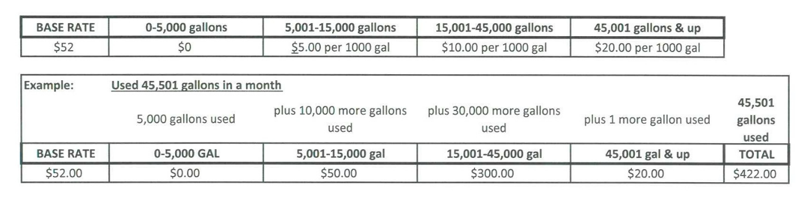
The Town uses water meters to measure the flow, with a register on top of the water meter to read the measured amount. There are some residences in town that need their register repaired/replaced, and the Town is currently fixing those by appointment.
There are a few spots in town which have used unexpected amounts of water, resulting in very high unexpected bills. In the cases of very large amounts of water use, the measured amount of water has passed through the meter. The passing of water is the only thing that will activate the meter. There could be a leak in the service line, after the meter and before the house. Sometimes these leaks could pop up in a yard, and sometimes elsewhere. Another source of higher than expected water usage could be that a hose was left on, or there is an appliance that is using excessive amounts of water, or there is a leak that needs repair in the house.
​
As a reminder, the service line from the water main is the property owner’s responsibility.
For more information please contact the Philipsburg Town Hall 406-859-3821

